

**yedek parça**

User Manual / Contents

**Getting Started**

Overview **3**

How to Use **4**

Build Process

Using Android Studio **5**

Admin Access **6**

User Access **7**

Log in and Sign in **8**

Purchase and Balance Transaction **9**

Uninstalling

Uninstalling the App **10**

Contact Us

Thank You for Using yedek parça **10**

# Overview

Welcome to yedek parça app! This manual will help you find your way around the excellent android app offered by Kerem KULAÇ, Felat ASLAN and M. Emin ÇAKIR. Whether you have just downloaded APK for the first time and are looking for a way to get started or you have been using our app for several days but still need some tips, this guide will help you to use easily . First, let us begin with a few notes on how to use the yedek parça app User Manual.

* The yedek parça app contains simple and useful UI.
* Log in and then easily perform the actions you want to do with the left menu.

## Minimum System Requirements

* Android 4.0 or later
* 12 MB space on the phone storage

**Note:** You must reach developers to get an APK and you can only use the app in Android phones.

# 

# How to Use

There is a left menu in the app. From that menu, we can reach all the features in that menu. Features: Account and balance information, My basket, My orders, Log out, Product categories. You can add basket all the wants and buy them. If you don’t have an account, you don’t have the worry. Because you can easily create an account.

## App Interface:

* + Log in and Sign in screen
  + Add component screen
  + Homepage
  + Account and balance information screen
  + My basket
  + My orders
  + Log out
  + Product categories

# Using Android Studio

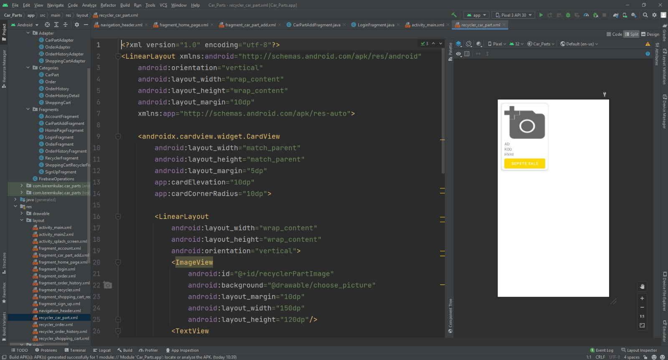

To able to build this app, we upload the shapes, background to Android Studio. We design interface and we code the app.

We designed all the UI for customer requirements. We coded algorithms in Java and Kotlin in Android Studio to be able to native support of Android app development. After testing everything we build the APK and uploaded to an Android Virtual Device and android phone to run customer tests. When the app is passed all the tests, we release an APK to the customer.

# Admin Access

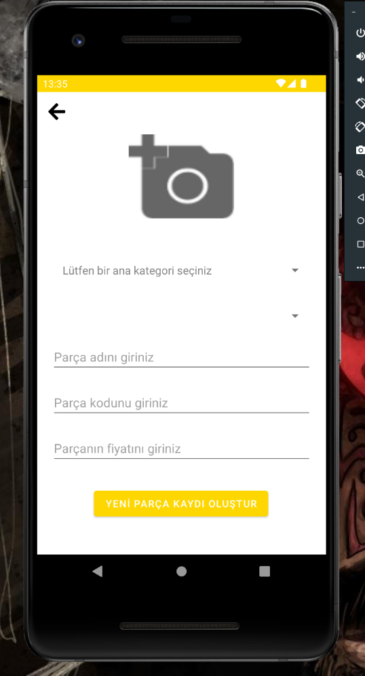

## Tips for Admin:

1. Add a product photo. Select a category and choose product
2. Click the “YENİ PARÇA KAYDI OLUŞTUR”.
3. It’s done.

# 

# User Access

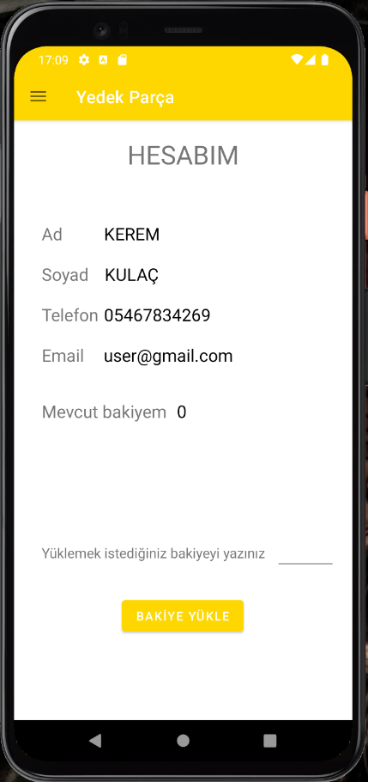

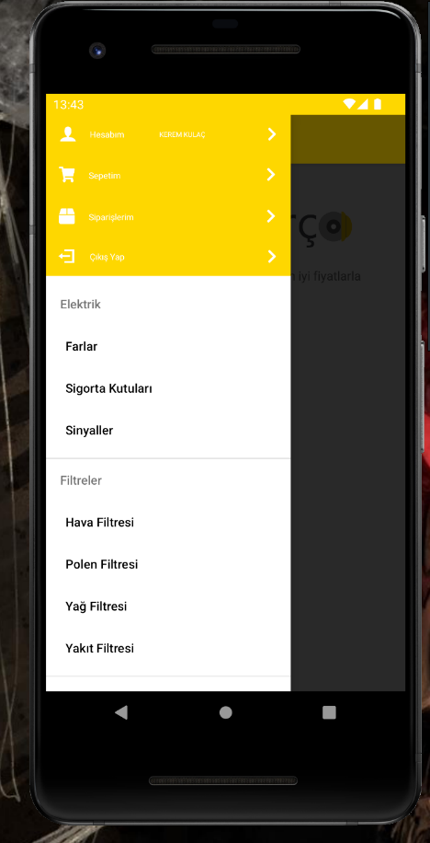

## Tips for Users:

1. After logging in, Homepage welcomes you.
2. You can easily access all the feature on side menu.

# 

# Log in and Sign in

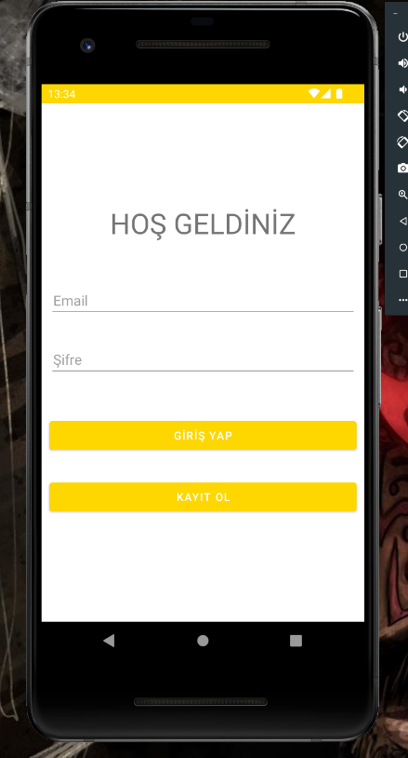

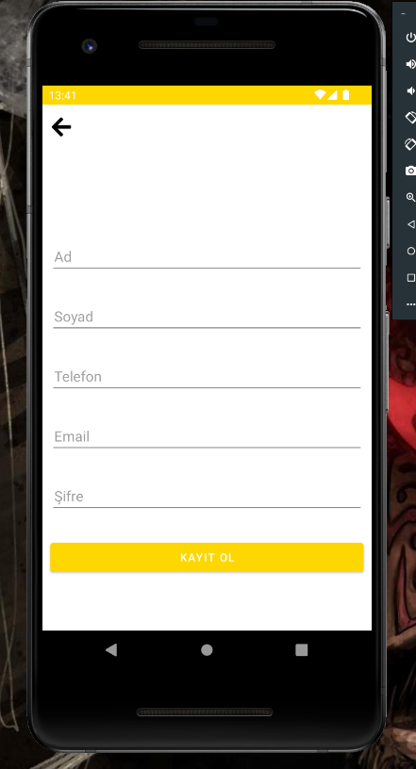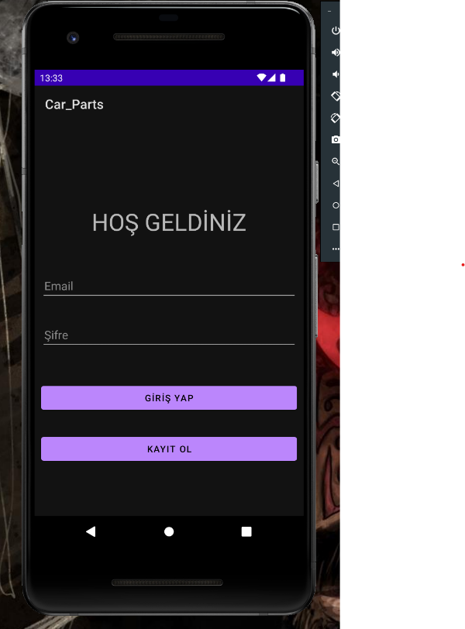

## Tips for hard log in and sign in:

1. If you have an account, you can log in easily.
2. If you don’t have an account, you can easily create an account (photo 2).
3. Also, we support dark mode.

# Purchase and Balance Transaction

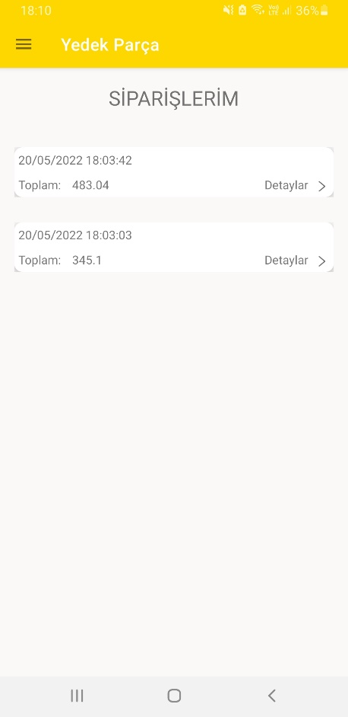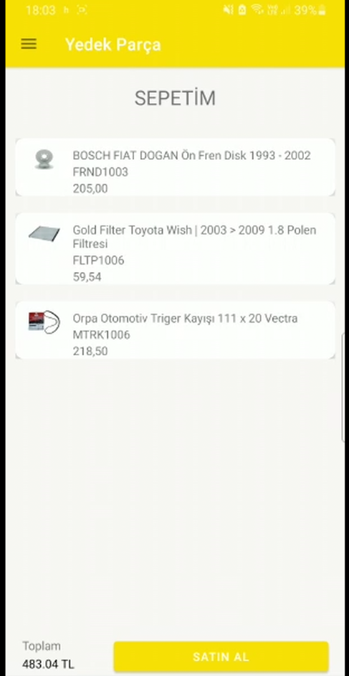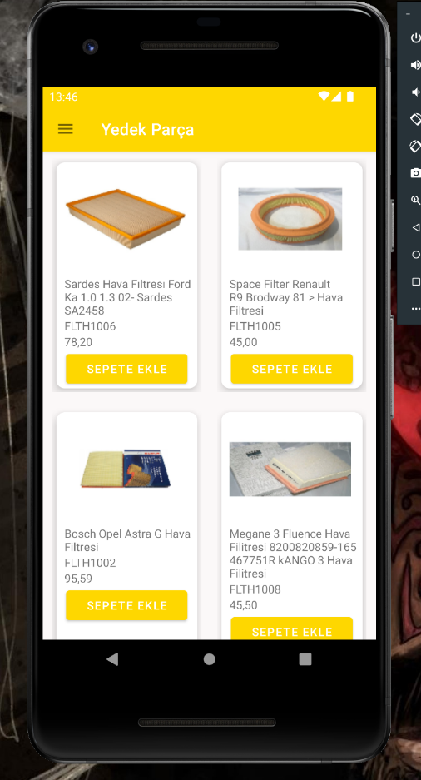

## Tips for purchasing process:

1. You can add the product you want to buy to the basket.
2. You can view price of product and buy them.
3. You can also view your past orders.

yedek parça

User Manual / Uninstalling

# Uninstalling the App

# 

1. Hold on the game icon.
2. Choose “App info”.
3. Click “Uninstall”.
4. Tap “Yes”.
5. It is removed.

For more information about the app, please contact us.

For more information about us and services we can provide, visit us at Manisa Celal Bayar University-Hasan Ferdi Turgutlu Technology Faculty. Turgutlu/Manisa

The Develop Team;

**Kerem KULAÇ**

**Felat ASLAN**

**M. Emin ÇAKIR**